Project Design Phase-II
Technology Stack (Architecture & Stack)

Date | 30 September 2026
Team ID | SWTID-2026-4949
Project Name | Weather Wise
Maximum Marks | 4 Marks

Technical Architecture:
The Deliverable shall include the architectural diagram as below and the information as per the table1 & table 2
Architecture: Weather forecasting and alert system
Reference: https://openweathermap.org/api
Guidelines:
Include all the processes (As an application logic / Technology Block)
Provide infrastructural demarcation (Local / Cloud)
Indicate external interfaces (third party API’s etc.)
Indicate Data Storage components / services
Indicate interface to machine learning models (if applicable)
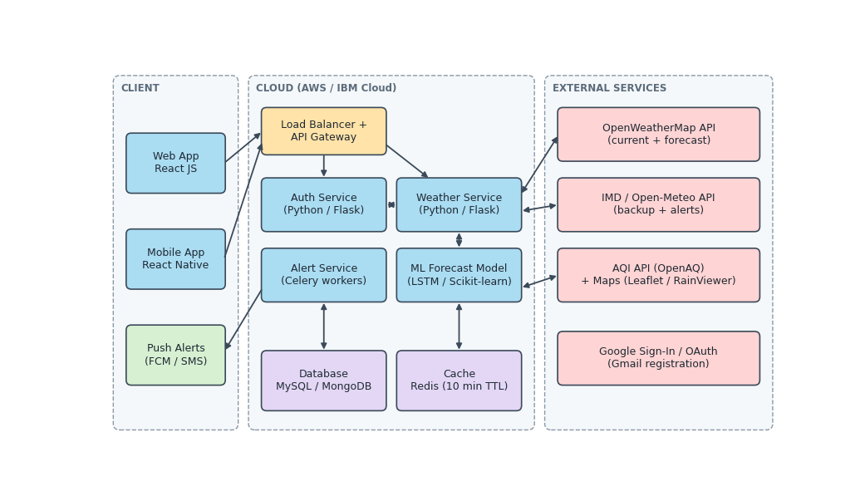

Table-1 : Components & Technologies:
S.No | Component | Description | Technology
 | User Interface | Web and mobile UI where users search or auto-detect a location and view current weather, hourly / 7-day forecast, radar maps and AQI | HTML, CSS, JavaScript / React JS, React Native
 | Application Logic-1 | User authentication, registration (email / Gmail), confirmation and location management | Python (Flask), JWT
 | Application Logic-2 | Weather service: fetches, cleans and serves current and forecast data; applies caching | Python (Flask / FastAPI), REST
 | Application Logic-3 | Alert service: compares forecasts with thresholds and sends severe-weather notifications | Celery + Redis queue, Firebase Cloud Messaging
 | Database | User profiles, saved locations, alert preferences, historical weather records | MySQL / MongoDB
 | Cloud Database | Managed database service on cloud for high availability and backups | IBM Cloudant / AWS RDS
 | File Storage | Storage for generated PDF / CSV weather reports and map tiles | AWS S3 / IBM Cloud Object Storage
 | External API-1 | Current weather and forecast data (temperature, humidity, wind, rain) | OpenWeatherMap API
 | External API-2 | Backup weather data, official warnings and air quality (AQI) | IMD / Open-Meteo API, OpenAQ API
 | Machine Learning Model | Short-term temperature and rainfall prediction to improve forecast accuracy from historical data | LSTM / Random Forest (Scikit-learn, TensorFlow)
 | Infrastructure (Server / Cloud) | Application deployment on local system / cloud  Local Server Configuration: 4 GB RAM, 2 vCPU, Ubuntu 22.04  Cloud Server Configuration: 2–4 containers (2 vCPU, 4 GB RAM each) with auto-scaling | Local, Docker, Kubernetes, AWS / IBM Cloud

Table-2: Application Characteristics:
S.No | Characteristics | Description | Technology
 | Open-Source Frameworks | Open-source frameworks used for the frontend, backend, ML and mapping | React JS, Flask, Celery, Scikit-learn, TensorFlow, Leaflet.js
 | Security Implementations | Password hashing, encrypted traffic, token-based access control, API key protection, input validation and firewall rules | SHA-256 / bcrypt, HTTPS (TLS), JWT, IAM controls, OWASP Top 10, WAF
 | Scalable Architecture | Micro-services (auth, weather, alert) that can be scaled independently; stateless APIs for horizontal scaling | Micro-services, Docker, Kubernetes auto-scaling
 | Availability | Multiple server instances behind a load balancer; fallback to backup weather API; database replication | Load balancer (NGINX / AWS ELB), multi-zone deployment, DB replication
 | Performance | Caching of frequent location queries, CDN for static assets and map tiles, asynchronous alert processing; target 500 requests / sec and under 2 s response | Redis cache, CDN (Cloudflare / CloudFront), Celery async queue

References:
https://c4model.com/
https://developer.ibm.com/patterns/online-order-processing-system-during-pandemic/
https://www.ibm.com/cloud/architecture
https://aws.amazon.com/architecture
https://medium.com/the-internal-startup/how-to-draw-useful-technical-architecture-diagrams-2d20c9fda90d

